- Lab Destruction Replacement Fee Schedule
The following table is from PCS Form 2-3184
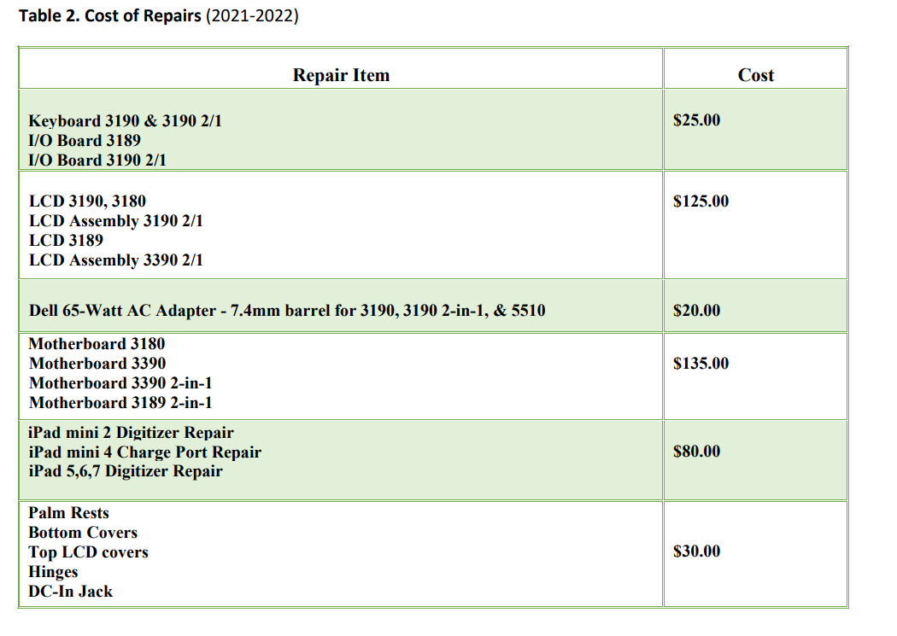
- Willfully broke a mouse = $10 replacement fee
- Willfully destroyed a cable = $15 replacement fee

